Arduino Solar Cell Tracker Final Project Report

De Anza College
E10 Introduction to Engineering
Names : Sammy Elzein, Huey Nguyen, Sovann Kay, Minnie Menon, Steven Nguyen, Krish Dilidili
E10 Group 4
Instructor : Saied Rafati
Due: 12/4/25

Table of Contents

Project Goal ————————————————————— Page 1
Market Survey ———————————————————— Page 2
Gantt Chart ————————————————————— Page 3
Test Description ——————————————————— Page 4
Part Status Order —————————————————— Page 6
Conclusion & Recommendation for Future Work —————— Page 7
Appendix —————————————————————— Page 8

Project Goal

The objective of this project was to create a machine that utilized Arduino coding and motors to change the direction of the solar cell. This would allow the solar cell to maximize its efficiency in collecting energy. The machine will also utilize servo motors to allow redirection for facing a light source. The specific objective this project was addressing was to find a safer alternative for power banks. Traditional power banks are known to be hazardous. In outdoor scenarios, the solar cell tracker is used to gain energy from the sun with the ability to redirect its own panels towards the light source. This is a smaller scale idea, where it could branch into more industrial ideas such as allowing larger solar panels to have a boost in efficiency with the use of tracking the sun.
The tasks that were performed from the start to the end of this project were distributed among the group. First, we had to identify what project to create and the purpose of creating it. After we decided on solar cell tracking, the design of the machine was the next step before coding the motors. In order for the tracker to work as intended, we needed to code the motors so that it was allowed to rotate along its own axis. We also needed to make this compatible with our 3D modeled foundation, where the motors would fit into and allow the machine to have a base.
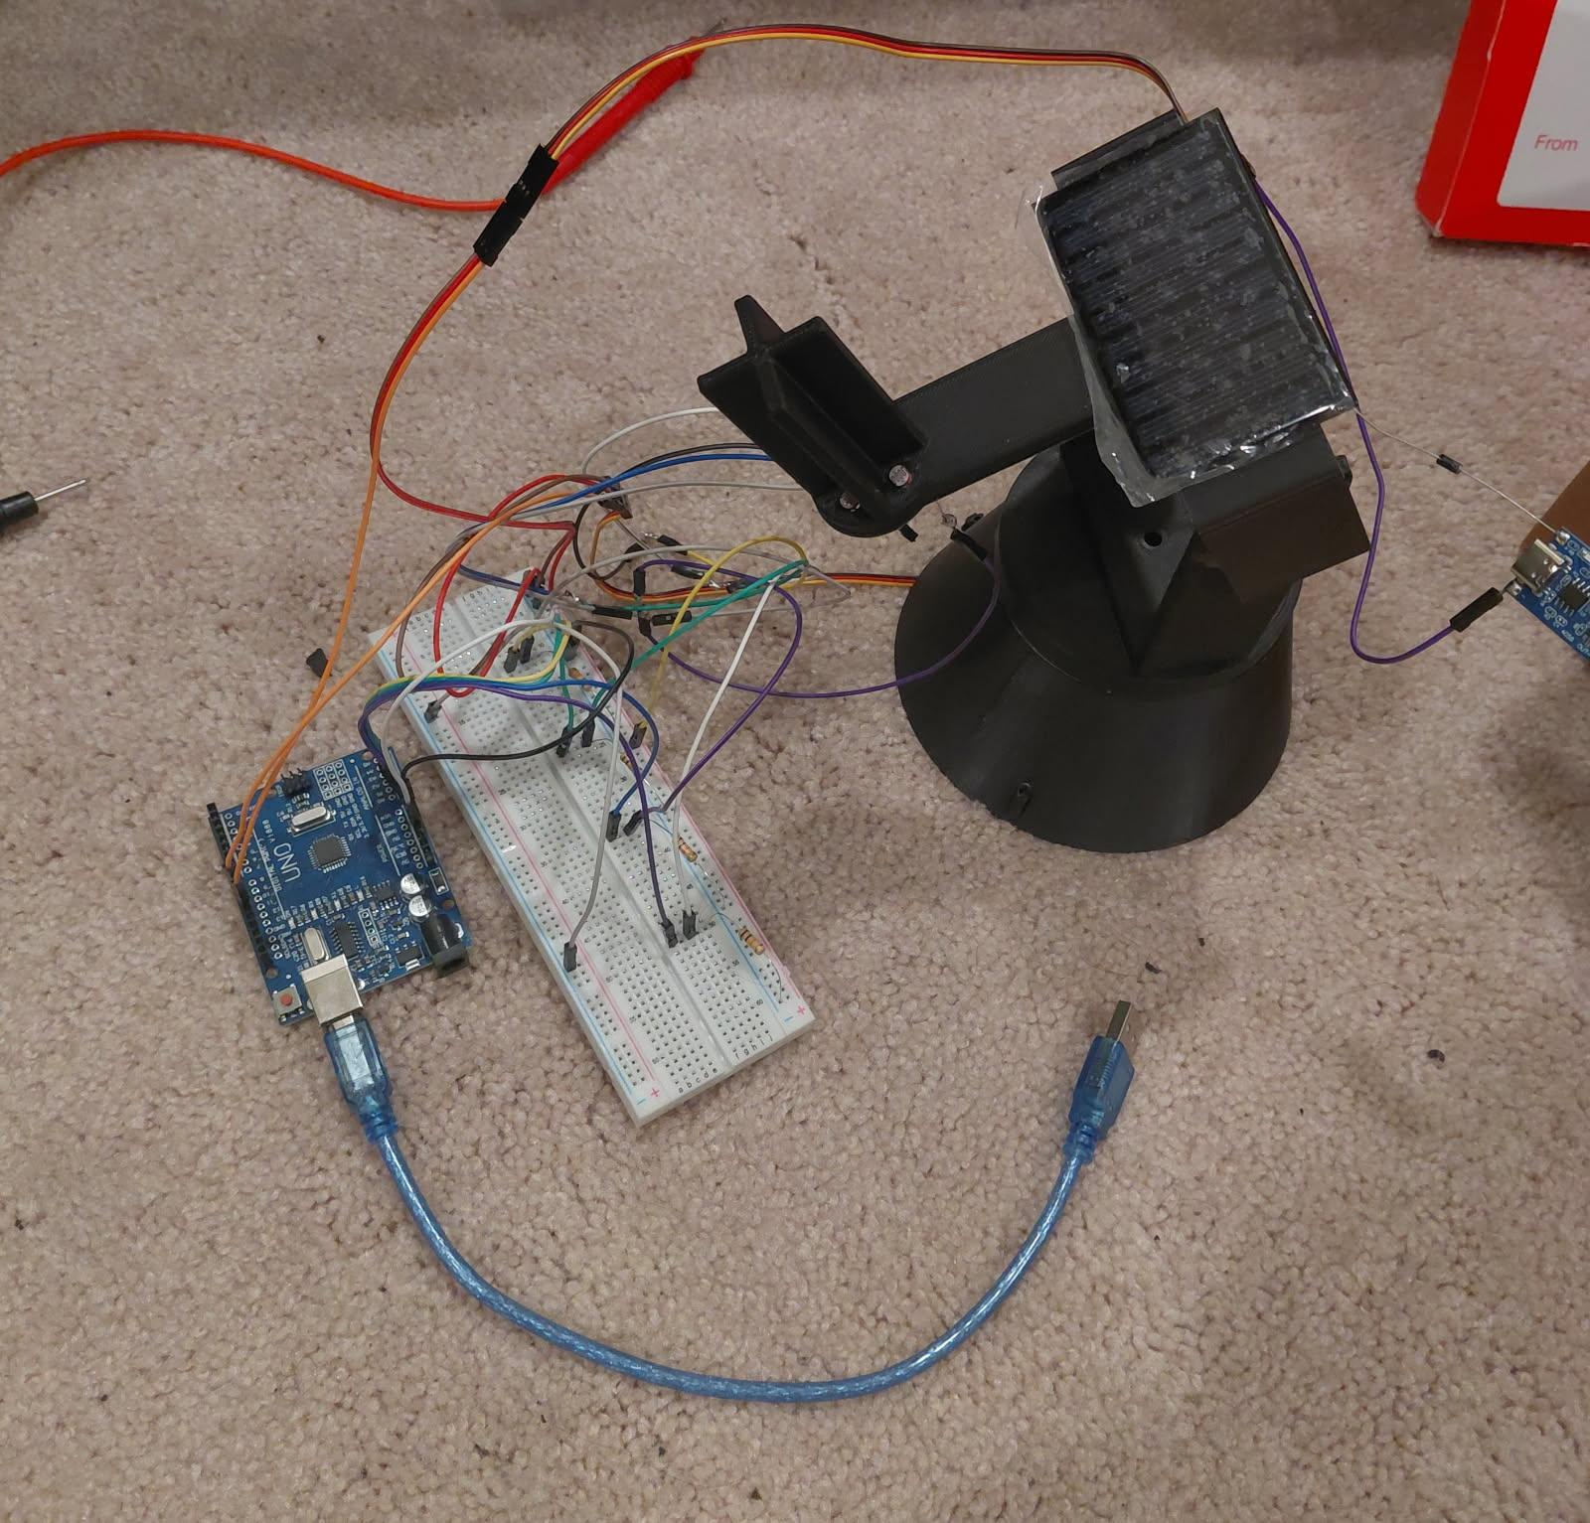
Market Survey
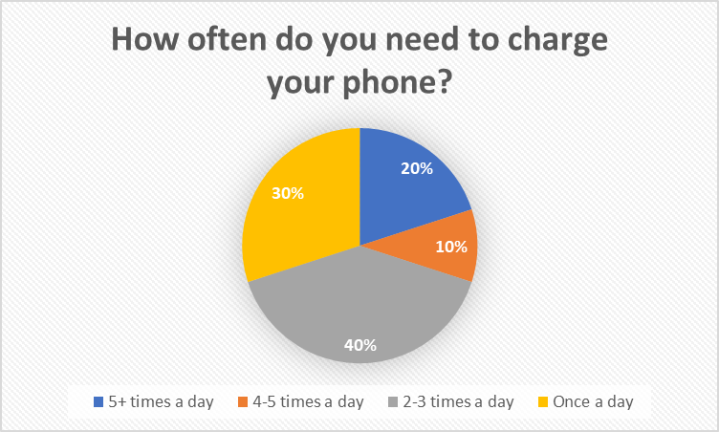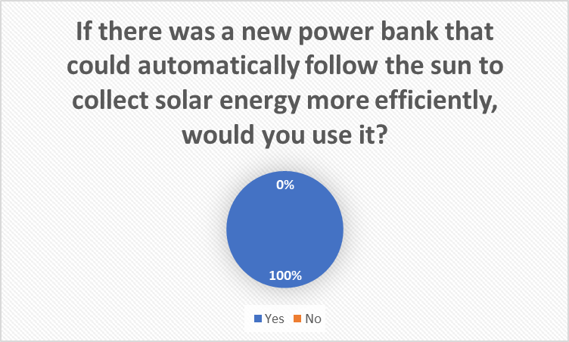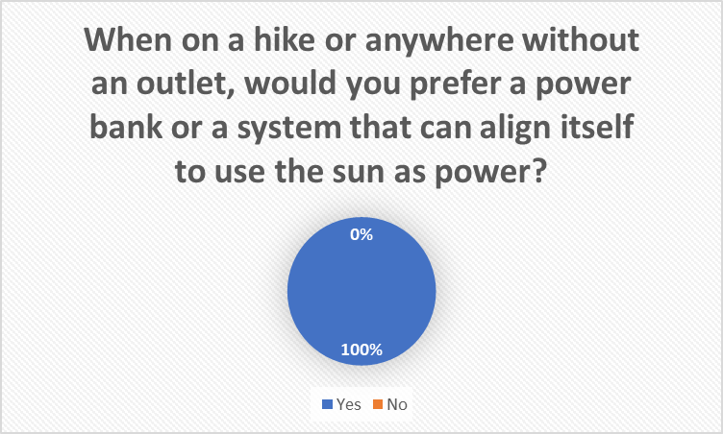
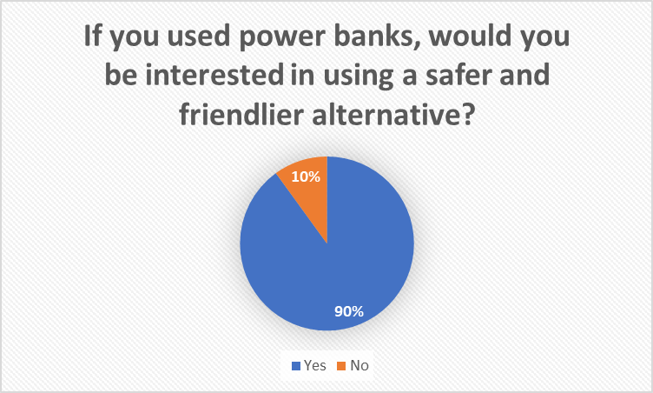 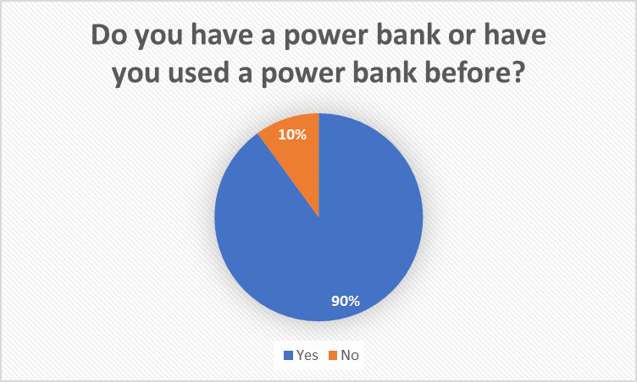 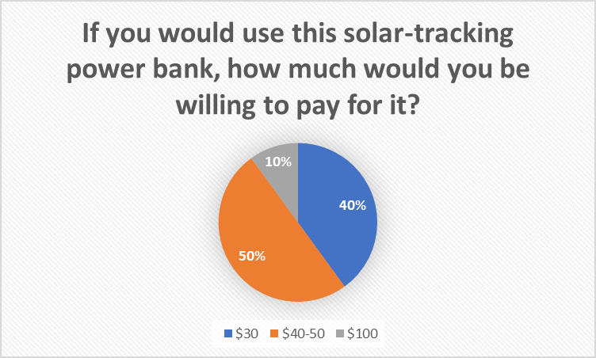
To better understand the need for our solar cell tracker, we used a Google Form where we surveyed 10 participants. We asked questions about charging habits, experience with power banks, and a willingness to pay for a better alternative. Our product was targeted towards students, hikers, and people who use their phones a lot; these groups rely on portable charging throughout the day. The data that was collected was put into pie charts to show the charging frequency, interests, and pricing expectations. This gave us a better idea of the budget as well as the customer’s needs. The data that was collected was real feedback, which gave the whole team meaningful opinions. This helped us in guiding our project designs and big decisions for the whole system.
The results of the survey showed that there was a strong interest in a more efficient outdoor charging solution. We found 60% of participants charged their phone at least 2–3 times per day, and 20% charged 5+ times daily. This showed that everyone relied on this portable power. 90% of respondents had used a power bank before, and nearly 100% said they would prefer or use a solar-tracking power bank when outdoors. Additionally, 50% were willing to pay $45–$50, while another 40% preferred a $30 price point, giving us a clear target budget range.
Gantt Chart

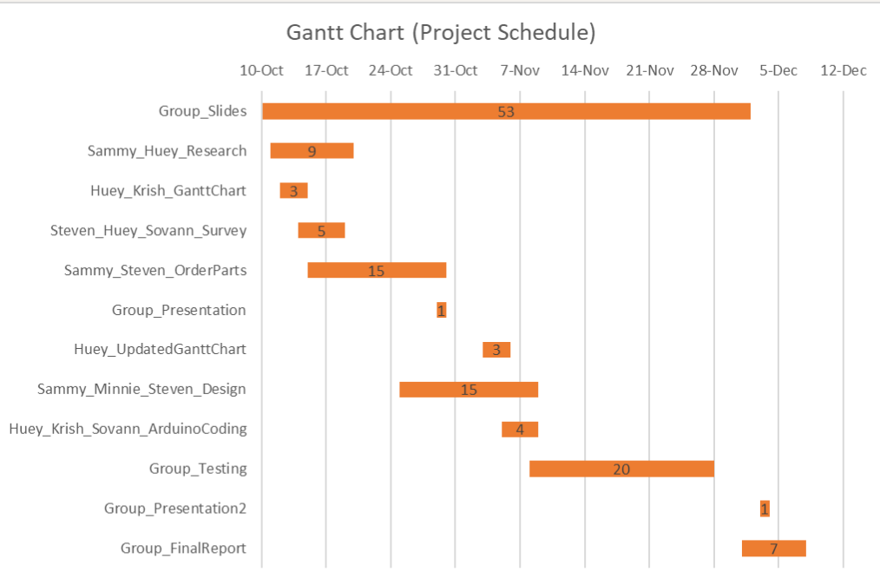

Based on our Gantt chart, some of the most challenging tasks were the group slides and the group testing. We worked on the group slides throughout the entirety of the project and the group testing we finished near the end of our timeline. Both of these tasks required coordination because everyone needed to find time outside of class to meet their assigned deadlines. Another reason these tasks were difficult was because they depended on other components of the project, such as ordering parts, coding and the design.
As a team we overcame these challenges by making sure to communicate. We used the Gantt chart to track our progress and to divide our work. We helped each other by checking in with each other frequently. Overall, this Gantt chart helped us to stay organized in order to meet our deadlines.
Test Description

After setting up the circuitry and assembling the project, we uploaded the code and tested the motor tracking capabilities. Instead of doing it outside and waiting for the sun’s motion, we used an artificial light source (phone flashlight) to test whether it could track the light or not. The battery charging component was skipped due to concerns of overcharging because of a missing part, but we would simply have left it outside during a sunny day and measured the voltage across the battery to see if it charged properly. We also would have checked if the battery was also enough to power the project itself while simultaneously getting charged.

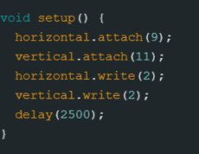
- This section sets all motor angles to near zero while assigning each motor a pin number

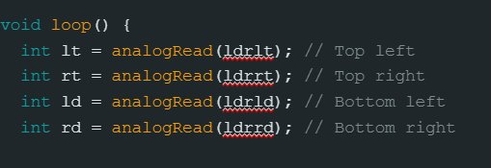
- This assigns each quadrant’s sensor a pin to read its analog value from

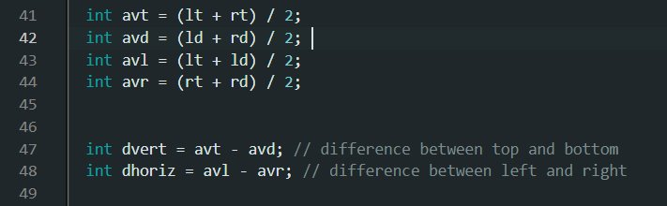
- This takes those values and calculates the average of each side of the quadrants

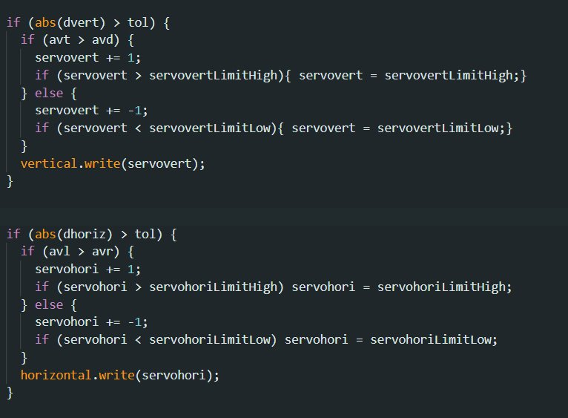

- This final part takes all of the values and compares them with each other. For example, for the first if statement, if the top side’s average value is higher than the bottom side’s, then it will increase the angle by 1 degree for each iteration in the void loop. This happens for all 4 directions.

The tracking was successful and was able to follow the phone flashlight. The horizontal rotation only had a range of ~160 degrees, but still rotated smoothly. The vertical motor was misplaced, and so only had a ~40 degree range (either looking up or to the side). High speed tracking worked properly meaning it followed the phone’s flashlight in real time. A delay in the arduino’s void loop code determines how fast it should be tracking it (30ms for fast tracking), meaning we can confirm that it could also be set to track a light source at much longer intervals.

Part Status / Order

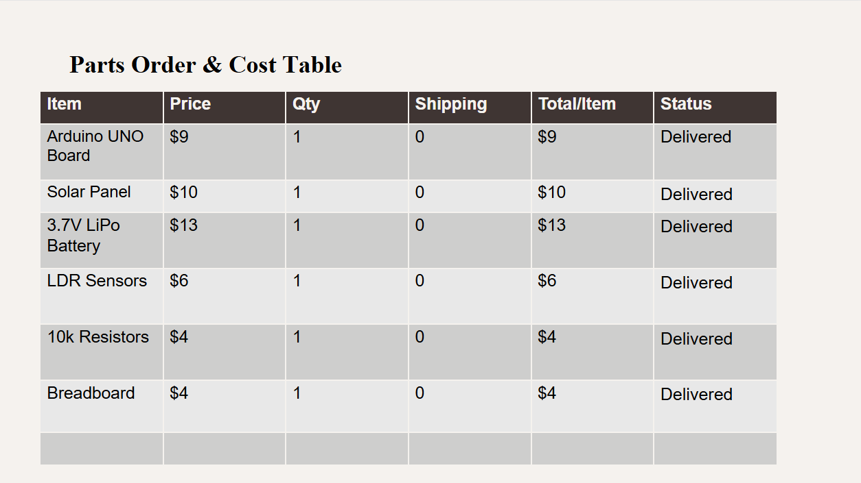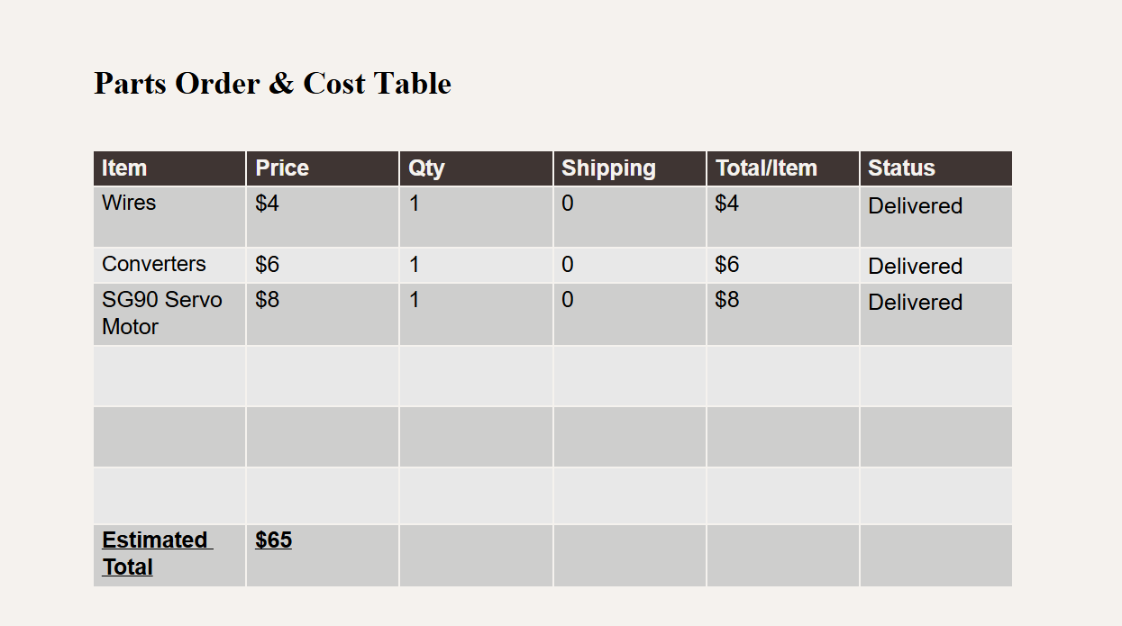

The parts order and cost table shows all the items needed for the project, how much they cost, and whether they arrived. Each part, like the Arduino board, solar panel, battery, sensors, resistors, breadboard, wires, converter, and servo motor are listed with its price and marked as
“Delivered”. Since every item was bought in a quantity of one and shipping was free, the total price for each part is the same as the price listed. This table helps keep everything organized so you can easily see what you bought and what has already arrived.
The obstacle we faced was making sure every part ordered was compatible with the project. It took some time to compare different items, check prices, and make sure the parts would work together. Another challenge was tracking deliveries, especially since some items arrived on different days; updating the table after each and every delivery, and making sure it’s accurate. The final obstacle that we faced was staying within the budget and making sure everybody can afford it, since some components had multiple price options. This required choosing items that were affordable but still reliable for the project.

Conclusion and Recommendation for Work

In conclusion, our Arduino Solar Tracker project allowed us to explore both the technical and teamwork aspects of engineering design. Throughout this process, we identified what worked well, what challenges we faced, and how our group collaborated to complete each part of the project. Our initial design goals were met, and several elements of the build performed exactly as expected. To begin with, one of the biggest successes was our coding and sensor system. The LDR sensors consistently detected changes in light, and the motor responded smoothly to those inputs. Additionally, our 3D-printed parts, including the base and mount, were accurately printed, allowing most components to fit. However, despite these successes, there were several aspects that did not work as smoothly as we hoped. One of the primary challenges we faced was the limitations with the motors range itself, preventing the tracker from going fully around. Another significant problem was it was unable to be powered by battery charge which was due to needing additional parts. In terms of group chemistry and member commitment, our team performed strongly overall. Each member was assigned a specific task by the group leader individually to complete and bring back to class. We were all able to communicate with each other and get the project done as a group.
Looking ahead, there are several recommendations that could greatly improve this project if it were to be continued or rebuilt from the beginning. From a technical perspective, one of the most important improvements would be adding components like a charge controller, voltage regulator, and a LCD to show the charging status. For a non-technical standpoint, ordering components earlier would reduce delays and give the team more time to refine our design. As well as establishing clearer roles at the beginning such as assigning one member to coding.

Appendix

- Evaluates teamwork by answering the following questions:
  - Who worked on each aspect of the project?
All the work for the project was distributed evenly. From the start of the project, the slides were made, and we worked on the slides as a group. Sammy and Huey worked on researching our topic. Huey and Krish made the first Gantt Chart while Steven, Huey, and Sovann worked on the survey. Sammy and Steven ordered the parts. Then we all presented as a group. After the first presentation, Huey worked on the updated Gantt chart while Sammy, Minnie, and Steven worked on the design for the project. While this happened, Huey, Krish, and Sovann worked on the Arduino Coding. As a group, we all built and tested our project. We all worked on the presentation and final report as a group.
  - Who contributed to each section of the report?
Sovann did the project goal. Huey did the market survey. Minnie did the Gantt Chart section. Sammy did the Test Description. Krish did the part status order. And Steven did the Conclusion.
  - Rank (on a scale of 5 to 1) your team's performance in the following six areas
(5 = We all did this all of the time, to 1 = did not do this at all)

Teamwork Skill | Performance Level
- Open and honest communication among members | 5
- Each individual carried his/her own weight | 4
- Collaboration in decision making | 4
- Team set goals and milestones | 5
- People listened to each other | 5
- Leadership was shared among the members | 5

